**SD – Mock Test**

1. First draw a flowchart and then write a C language code (use if-else) to do the following task: Get a temperature value in degrees Celsius from the user. Then the user can select whether to convert the temperature value to Fahrenheit (by entering F) or Kelvin (by entering K). You should output the corresponding temperature value requested by the user. You may use the following equations for the conversion.

Tf = 59 Tc + 32

Tk = Tc + 273.15 (1)

Your script should behave like the following:

Enter temperature in Celsius: 0  
Do you want to convert K or F?: F  
The temperature value in Fahrenheit is 32.00.

1. First draw a flowchart and then write a C language code (use if-elif-else) to perform the following task: The Reynolds number (Re) is used in fluid dynamics to determine the nature of a fluid flow. For an internal flow (e.g. water flow through a pipe), the flow can be categorized as given in the following table. The flow region changes with the Reynolds number.

|  |  |
| --- | --- |
| Re ≤ 2300 | Laminar Region |
| 2300 < Re ≤ 4000 | Transition Region |

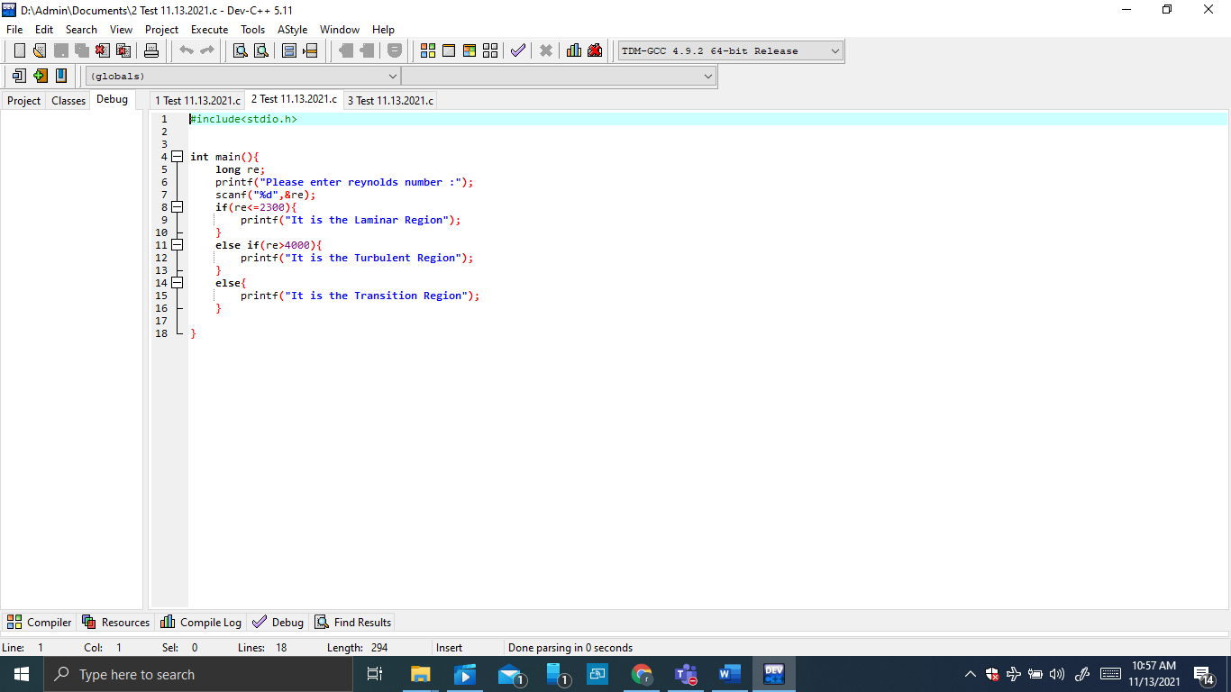

1. First draw a flowchart and then write a C language code (using a suitable loop construct) to do the flowing task. Get the number of rows from the user and print 10 stars according to the given pattern in each row for the number of rows given by the user. Your script should behave like the following:

Enter the number of rows : 5

**********

**********

**********

